EX. NO: 6
IMPLEMENTATION OF DES
Aim:
To write a java program to implement Data Encryption Standard (DES) using C
Language.
ALGORITHM:
STEP-1: Read the 64-bit plain text.
STEP-2: Split it into two 32-bit blocks and store it in two different arrays.
STEP-3: Perform XOR operation between these two arrays.
STEP-4: The output obtained is stored as the second 32-bit sequence and the original
second 32-bit sequence forms the first part.
STEP-5: Thus the encrypted 64-bit cipher text is obtained in this way. Repeat the same
process for the remaining plain text characters.
Program:
import java.util.Scanner;
import java.util.Random;
import java.util.Base64;
import java.security.SecureRandom;
import javax.crypto.Cipher;
import javax.crypto.KeyGenerator;
import javax.crypto.SecretKey;
import javax.crypto.spec.SecretKeySpec;
public class DESDemo {
static byte[] raw;
// Generate DES Key
public static void generateKey() throws Exception {
Random r = new Random();
int num = r.nextInt(10000);

byte[] seed = String.valueOf(num).getBytes();
KeyGenerator keyGen = KeyGenerator.getInstance("DES");
SecureRandom sr = SecureRandom.getInstance("SHA1PRNG");
sr.setSeed(seed);
keyGen.init(56, sr);
SecretKey key = keyGen.generateKey();
raw = key.getEncoded();
System.out.println("DES Key: " + Base64.getEncoder().encodeToString(raw));
}
// Encrypt
public static byte[] encrypt(byte[] raw, byte[] plainText) throws Exception {
SecretKeySpec keySpec = new SecretKeySpec(raw, "DES");
Cipher cipher = Cipher.getInstance("DES");
cipher.init(Cipher.ENCRYPT_MODE, keySpec);
return cipher.doFinal(plainText);
}
// Decrypt
public static byte[] decrypt(byte[] raw, byte[] cipherText) throws Exception {
SecretKeySpec keySpec = new SecretKeySpec(raw, "DES");
Cipher cipher = Cipher.getInstance("DES");
cipher.init(Cipher.DECRYPT_MODE, keySpec);
return cipher.doFinal(cipherText);
}
public static void main(String[] args) {
try {
Scanner sc = new Scanner(System.in);

generateKey();
System.out.print("Enter Message: ");
String message = sc.nextLine();
byte[] encrypted = encrypt(raw, message.getBytes());
String encryptedText = Base64.getEncoder().encodeToString(encrypted);
System.out.println("Encrypted Message: " + encryptedText)
byte[] decrypted = decrypt(raw, encrypted)
System.out.println("Decrypted Message: " + new String(decrypted));
sc.close();
} catch (Exception e) {
e.printStackTrace();
}
}
}
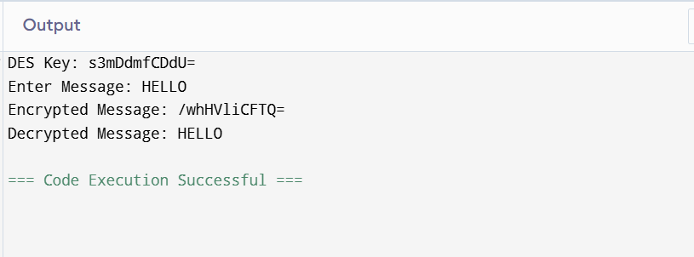
Result:
Thus the data encryption standard algorithm had been implemented successfully
using java language.

